**INTCDE21ID008**

**STAGE-3**

**916398 – SAAHIL TOMAR**

**Day 68 –** Angular

SESSION - 1

**Hands-On:**

Define JavaScript object for employee

Employee.js

var firstname;

var lastname;

var salary;

var permenantstaff;

function employee(fname, lname, salary, permenantstaff)

{

this.firstname = fname;

this.lastname - lname;

this.salary = salary;

this.permenantstaff = permenantstaff;

}

var empobj = new employee("John", "Stoke", 5000, false);

console.log('First Name:' + firstname + '\n' + "Last Name:" + lastname);

Employee.html

< !DOCTYPE html >

< html lang = "en" >

< head >

< meta charset = "UTF-8" >

< meta http - equiv = "X-UA-Compatible" content = "IE=edge" >

< meta name = "viewport" content = "width=device-width, initial-scale=1.0" >

< title > Document </ title >

</ head >

< script >

var firstname;

var lastname;

var salary;

var permenantstaff;

function employee(fname, lname, salary, permenantstaff)

{

this.firstname = fname;

this.lastname = lname;

this.salary = salary;

this.permenantstaff = permenantstaff;

}

var empobj = new employee("John", "Stoke", 5000, false);

console.log(empobj);

</ script >

< body >

</ body >

</ html >

**OUTPUT**

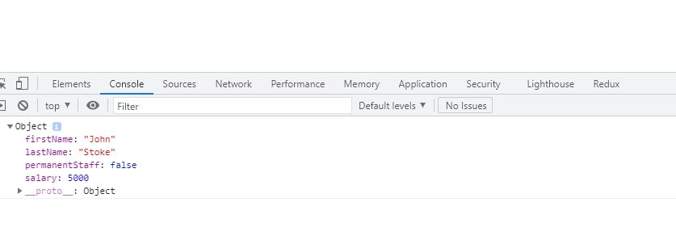

Define JSON for employee details and parse

Json file

const text = '{"fname":"John", "lname":"Stoke", "salary":5000,"pstaff":false}';

const obj = JSON.parse(text);

console.log("First Name:" + obj.fname);

console.log("Last Name:" + obj.lname);

console.log("Salary:" + obj.salary);

console.log("Permenant Staff:" + obj.pstaff);

employee.html

< !DOCTYPE html >

< html lang = "en" >

< head >

< meta charset = "UTF-8" >

< meta http - equiv = "X-UA-Compatible" content = "IE=edge" >

< meta name = "viewport" content = "width=device-width, initial-scale=1.0" >

< title > Document </ title >

</ head >

< script >

const text = '{"fname":"John", "lname":"Stoke", "salary":5000,"pstaff":false}';

const obj = JSON.parse(text);

console.log("First Name:" + obj.fname);

console.log("Last Name:" + obj.lname);

console.log("Salary:" + obj.salary);

console.log("Permenant Staff:" + obj.pstaff);

</ script >

< body >

</ body >

</ html >

**OUTPUT**

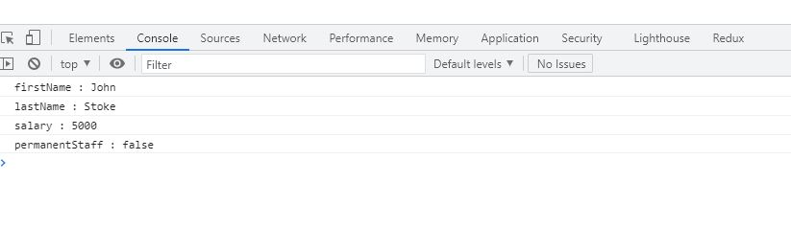

Add department details to employee

Json file:

const text = '{"fname":"John", "lname":"Stoke", "salary":5000,"pstaff":true,"deptid":4,"deptname":"tax"}';

const obj = JSON.parse(text);

obj.deptid = 3;

obj.deptname = "Payroll";

console.log("First Name:" + obj.fname);

console.log("Last Name:" + obj.lname);

console.log("Salary:" + obj.salary);

console.log("Permenant Staff:" + obj.pstaff);

console.log("Department Id:" + obj.deptid);

console.log("Department Namae:" + obj.deptname);

employee.html

< !DOCTYPE html >

< html lang = "en" >

< head >

< meta charset = "UTF-8" >

< meta http - equiv = "X-UA-Compatible" content = "IE=edge" >

< meta name = "viewport" content = "width=device-width, initial-scale=1.0" >

< title > Document </ title >

</ head >

< script >

const text = '{"fname":"John", "lname":"Stoke", "salary":5000,"pstaff":true,"deptid":4,"deptname":"tax"}';

const obj = JSON.parse(text);

obj.deptid = 3;

obj.deptname = "Payroll";

console.log("First Name:" + obj.fname);

console.log("Last Name:" + obj.lname);

console.log("Salary:" + obj.salary);

console.log("Permenant Staff:" + obj.pstaff);

console.log("Department Id:" + obj.deptid);

console.log("Department Namae:" + obj.deptname);

</ script >

< body >

</ body >

</ html >

**OUTPUT**

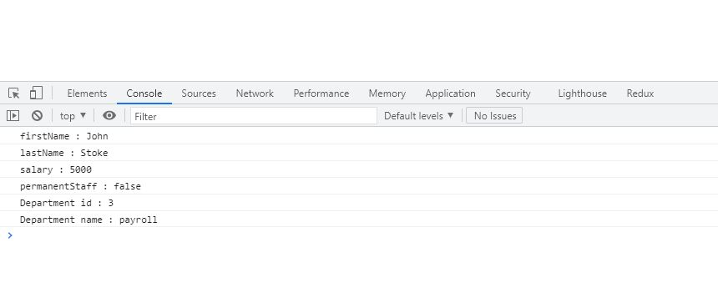

JSON - Add skill details to employee

< script >

const text = '{"fname":"John", "lname":"Stoke", "salary":5000,"pstaff":true,"deptid":4,"deptname":"tax","skills":[{"id":"1", "value":"HTML"},{"id":"2", "value":"CSS"},{"id":"2", "value":"Javascript"}]}';

const obj = JSON.parse(text);

obj.deptid = 3;

obj.deptname = "Payroll";

console.log("First Name:" + obj.fname);

console.log("Last Name:" + obj.lname);

console.log("Salary:" + obj.salary);

console.log("Permenant Staff:" + obj.pstaff);

console.log("Department Id:" + obj.deptid);

console.log("Department Namae:" + obj.deptname);

for (var i = 0; i < obj.skills.length; i++)

{

console.log("Skill " + (i + 1) + ":" + obj.skills[i].id + ", " + obj.skills[i].value)

}

</ script >

**OUTPUT**

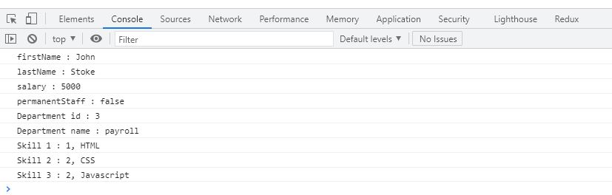

SESSION – 2

Include Department details in Employee and display

Employee.ts

export interface employee

{

id:number;

name:string;

salary:number;

permanent:boolean;

departmentid:number

}

Employee_test.ts:

import

{ employee}

from './employee'

var emp:employee = {

id: 3,

name: "John",

salary: 5000,

permanent: true,

departmentid: 1,

}

console.log("id : " + emp.id);

console.log("name : " + emp.name);

console.log("salary : " + emp.salary);

console.log("permanent : " + emp.permanent);

console.log("Department Id : " + emp.departmentid);

employee.html

< !DOCTYPE html >

< html lang = "en" >

< head >

< meta charset = "UTF-8" >

< meta http - equiv = "X-UA-Compatible" content = "IE=edge" >

< meta name = "viewport" content = "width=device-width, initial-scale=1.0" >

< title > Document </ title >

< script >

var emp = {

id: 3,

name: "John",

salary: 5000,

permanent: true,

departmentid: 1,

departmentname: "Payroll"

};

console.log("id : " + emp.id);

console.log("name : " + emp.name);

console.log("salary : " + emp.salary);

console.log("permanent : " + emp.permanent);

console.log("Department Id : " + emp.departmentid);

</ script >

< body >

</ body >

</ html >

**OUTPUT**

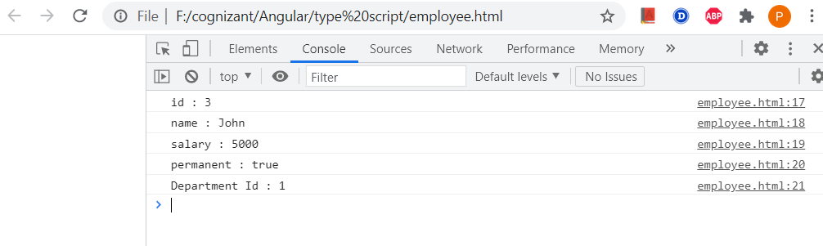

employee.ts

import

{ Department }

from './Department';

export class Employee implements Department

{

id:number;

name:string;

salary:number;

permanent:boolean;

constructor(id:number, name:string, salary:number, permanent:boolean){

this.id = id;

this.name = name;

this.salary = salary;

this.permanent = permanent;

}

}

Department.ts

export interface Department

{

id:number;

name:string;

}

employee-test.ts

import

{ Employee}

from './Employee'

import

{ Department }

from './Department';

var emp:Employee = {

id: 3,

name: "John",

salary: 5000,

permanent: true,

departmentid: 1,

departmentname: "Payroll"

}

console.log("id : " + emp.id);

console.log("name : " + emp.name);

console.log("salary : " + emp.salary);

console.log("permanent : " + emp.permanent);

var dept:Department = {

id: 1,

name: "Payroll",

}

console.log("Department Id : " + emp.departmentid);

console.log("Department Name : " + emp.departmentname);

employee.html

< !DOCTYPE html >

< html lang = "en" >

< head >

< meta charset = "UTF-8" >

< meta http - equiv = "X-UA-Compatible" content = "IE=edge" >

< meta name = "viewport" content = "width=device-width, initial-scale=1.0" >

< title > Document </ title >

< script >

var emp = {

id: 3,

name: "John",

salary: 5000,

permanent: true,

departmentid: 1,

departmentname: "Payroll"

};

console.log("id : " + emp.id);

console.log("name : " + emp.name);

console.log("salary : " + emp.salary);

console.log("permanent : " + emp.permanent);

console.log("Department Id : " + emp.departmentid);

console.log("Department Name : " + emp.departmentname);

</ script >

< body >

</ body >

</ html >

**OUTPUT**

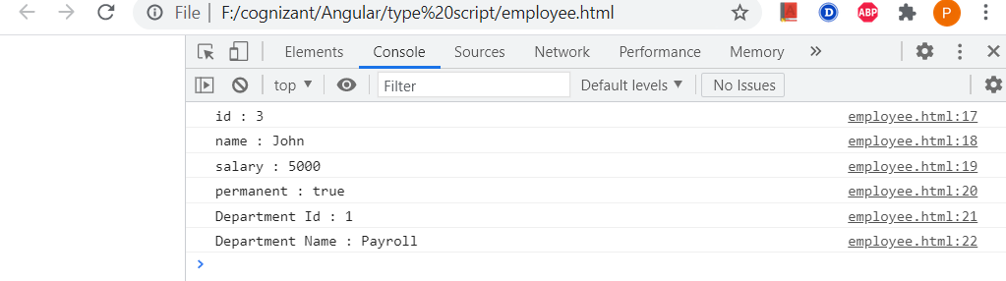

TypeScript data types and interface – Include Skill details in Employee and display

skill.ts

export interface Skill

{

id:number;

name:string;

}

employee.ts

import

{ Employee }

from './Employee';

import

{ Skill }

from './Skill';

import

{ Department }

from './Department';

var emp1 = new Employee(123, "John", 10000, true);

console.log("id: " + emp1.id);

console.log("name: " + emp1.name);

console.log("salary: " + emp1.salary);

console.log("permanent: " + emp1.permanent);

var dept:Department = {

id: 1,

name: "Payroll",

}

console.log("Department id : " + dept.id);

console.log("Department name : " + dept.name);

var skill1:Skill = {

id: 1,

name: "HTML",

}

var skill2:Skill = {

id: 2,

name: "CSS",

}

var skill3:Skill = {

id: 3,

name: "JavaScript",

}

console.log("Skill[0]:" + skill1.id + ", " + skill1.name);

console.log("Skill[1]:" + skill2.id + ", " + skill2.name);

console.log("Skill[2]:" + skill3.id + ", " + skill3.name);

Employee-test.ts

import

{ Employee }

from './Employee';

var emp1 = new Employee(1, "HTML");

var emp2 = new Employee(2, "CSS");

var emp3 = new Employee(3, "Javascript");

console.log("Skill 1: " + emp1.id + ", " + emp1.name);

console.log("Skill 2: " + emp2.id + ", " + emp2.name);

console.log("Skill 3: " + emp3.id + ", " + emp3.name);

**OUTPUT**

